How to write a plain language summary of a Cochrane intervention review

14th September 2020

(Please send any comments to the template to Claire Glenton (claire.glenton@fhi.no) at Cochrane Norway)

Plain language summary template
In this document, we describe how to write a plain language summary for a Cochrane Intervention Review. We suggest sub-headings and provide a description of the content required under each sub-heading.
The instructions in this template aim to supplement the Standards for the reporting of Plain Language Summaries in new Cochrane Intervention Reviews (PLEACS).
The recommended length of a Cochrane plain language summary is between 400 and 700 words.

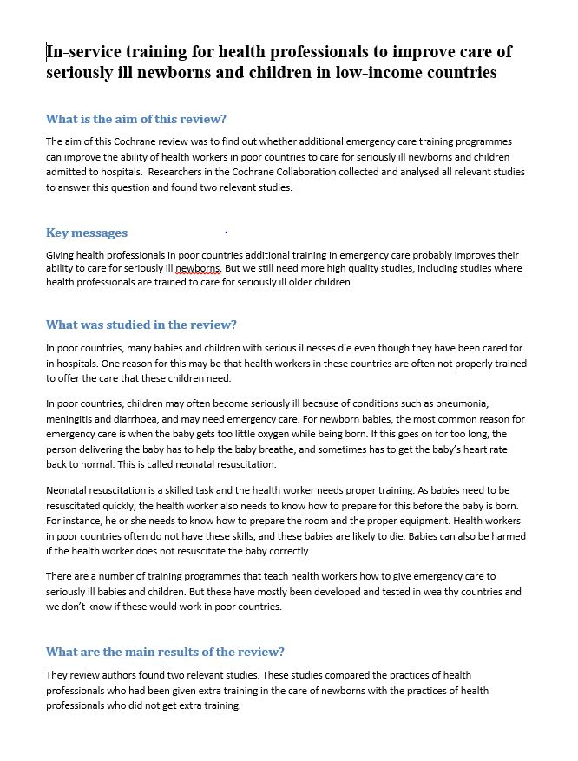
Example 1: This example has been written with the help of the plain language summary template and is based on the following review:
Opiyo N, English M. In-service training for health professionals to improve care of the seriously ill newborn or child in low and middle-income countries (Review). Cochrane Database of Systematic Reviews 2015 (In press).

See also Appendix 2 for another example of a plain language summary.
A
B
C
D
E

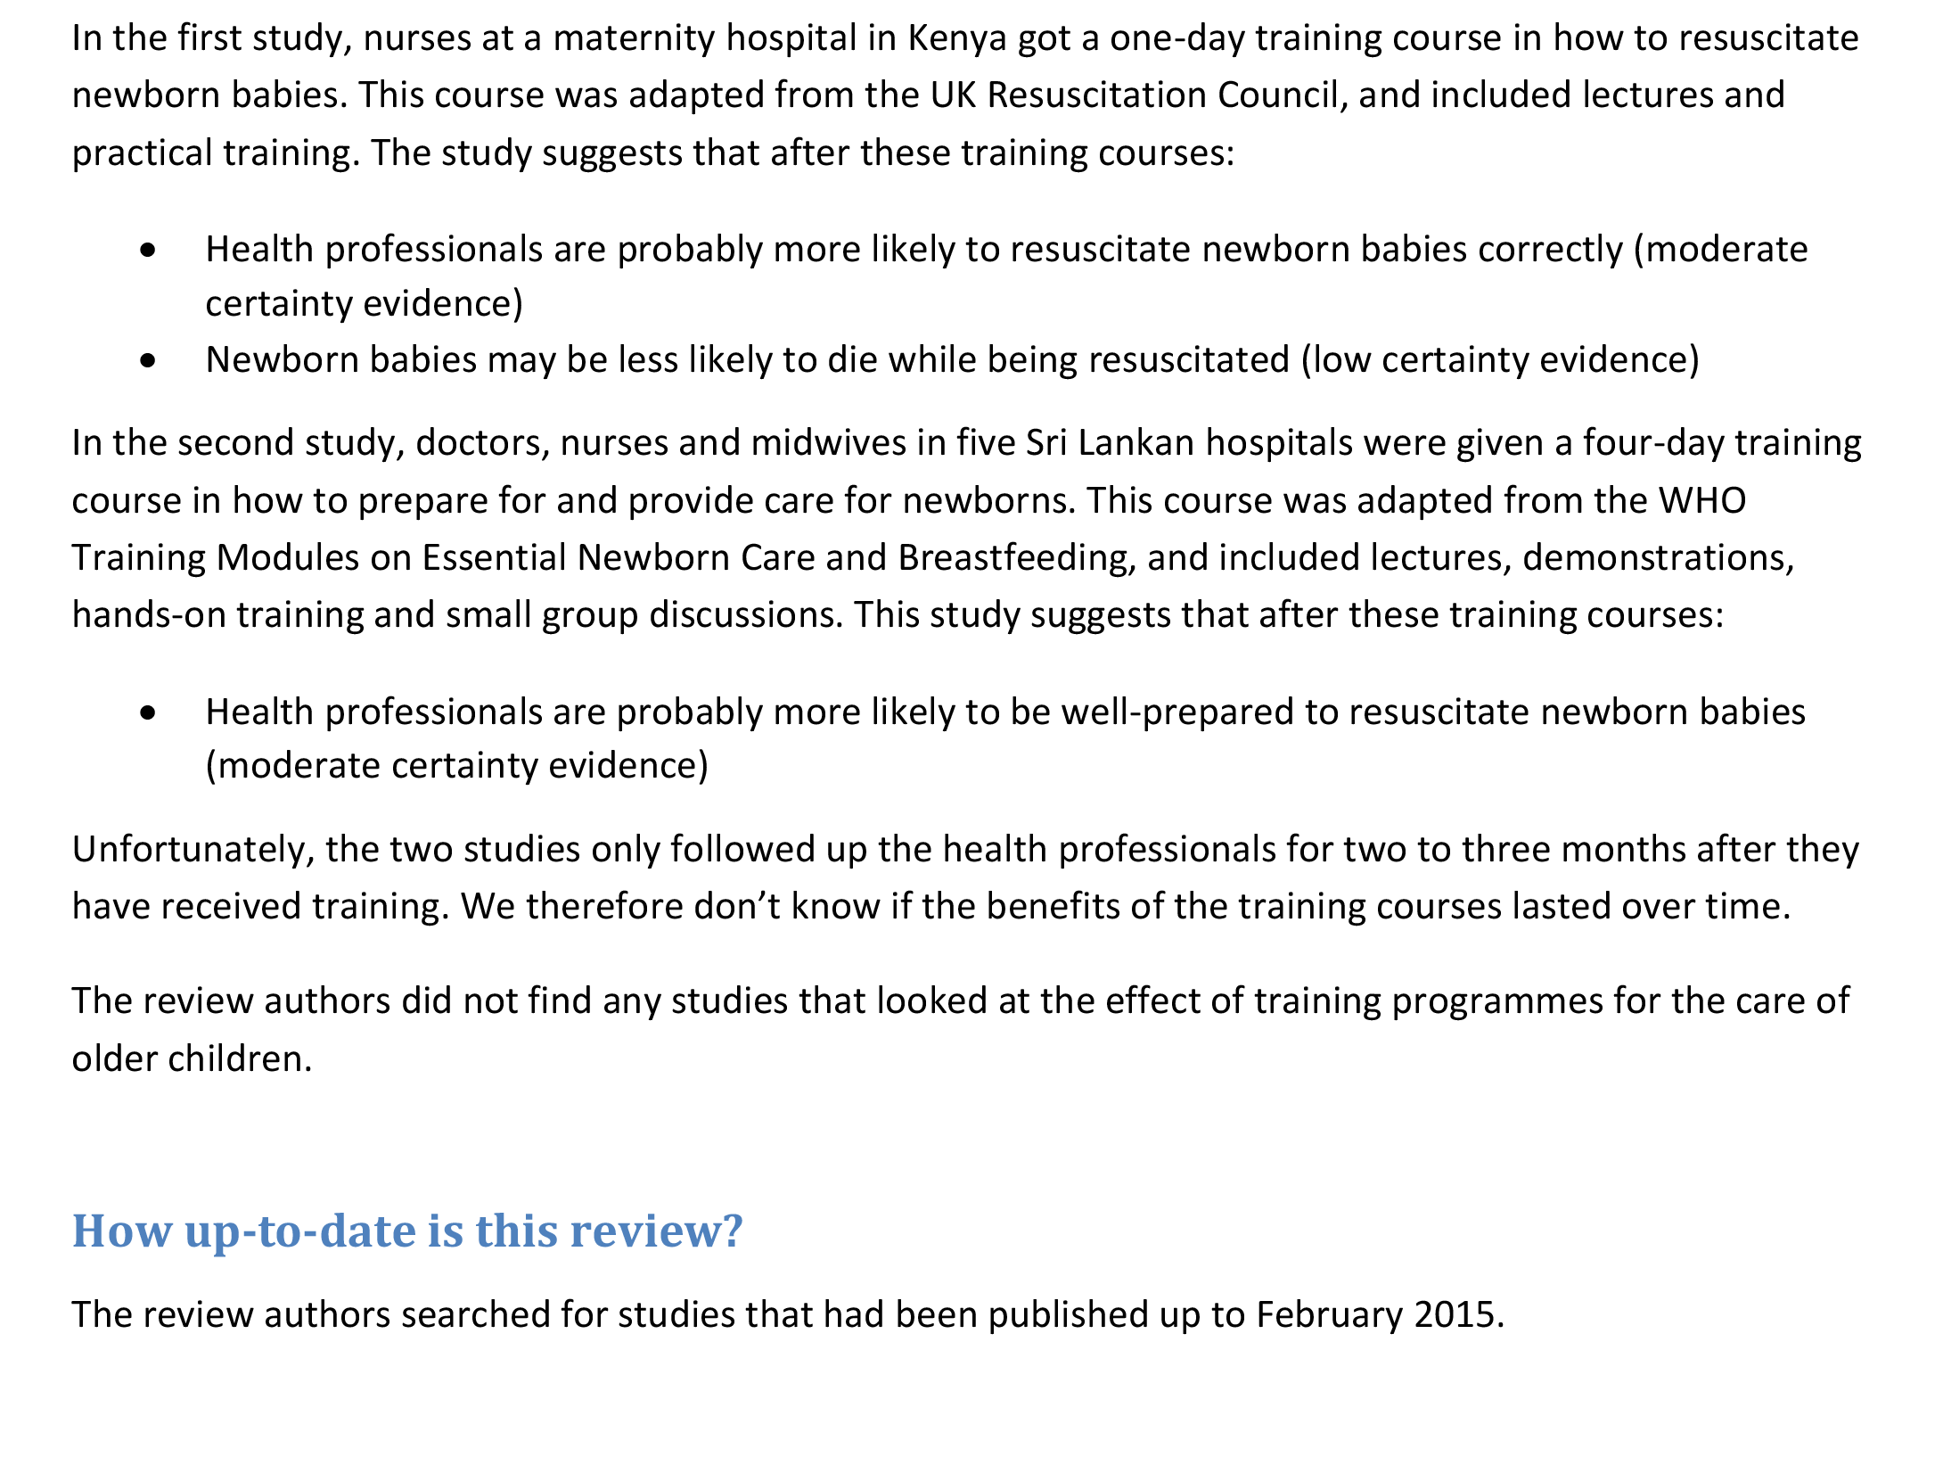
F

Instructions

Review title
A
If the review title is difficult to understand, for instance if it includes technical terms or jargon, consider re-writing it in plain language. If you do make changes, consider whether these should also be made to the main review title.
Suggested sub-heading: “What is the aim of this review?”
B
People do not always understand that the results of a plain language summary come from a systematic review rather than a single study. Some also wrongly assume that the review authors have carried out the studies themselves. We therefore suggest that you use an introductory sentence such as:
“The aim of this Cochrane Review was to find out if [….]. The review authors collected and analysed all relevant studies to answer this question and found [X#] studies.”

Suggested sub-heading: “Key messages”
C
In this section you should only present a brief summary of the results. This summary should include a reference to the quality or certainty of the evidence, and any important research gaps. It should not include recommendations. NB! Summarising the main results may involve some interpretation and caution is required!
The results for each main outcome should be presented in the section called “What are the main results”.

Suggested sub-heading: “What was studied in the review?”
D
In this section, you should briefly describe what the review aimed to address.
Consider which of the following elements need explanation:
- Why is this particular topic important?
- What was the population(s)/health problem(s) addressed in the review?
- What was the intervention(s) addressed in the review and what was it compared to?
- What were the outcomes addressed in the review?
Avoid research jargon here and in the rest of the Summary:
- Refer to “study” rather than “trial”
- Use the name of the intervention instead of “intervention”. If it is a long name, consider terms such as “the treatment”, “the programme”, “the healthcare service”
- Use the name of the outcome instead of “outcome”
- Explain briefly, either here or at the top of your plain language summary, how the review topic was identified. For instance, was the review commissioned to support a particular guideline process; in response to gaps identified in other studies or reviews; or in response to the review authors’ experiences as healthcare providers or service users?

Where to look for this information: You will find information about the population, intervention and outcomes that the Review aims to cover in the Background section and the Methods section.

Suggested sub-heading: “What are the main results of the review?”
E

Describing the included studies
In this section you should briefly describe what the review actually found. It may be enough to give information about how many studies you included and where they were set. Sometimes, you may also need to give more specific information about the intervention and comparison group and the study population. For instance, if the included studies only covered certain sub-groups of the population or certain types of the intervention, this should be mentioned. You may also need to mention the funding sources of the included studies. For instance:

“The review authors found [x#] relevant studies. [X#] were from [country/setting] and [x#] were from [country/setting]. These studies compared [intervention] with [comparison] for [population]. [x#] of the studies were funded by the manufacturer while [x#] were funded by government agencies.”

Where to look for this information: You will find information about the populations, interventions and outcomes that the included studies covered in the Review’s Results section (under “Included Studies”) and in the Characteristics of Included Studies Table. You may also find information about how the studies were funded in the Characteristics of Included Studies Table.

Reporting the effect of the interventions

Principles when reporting the effects of the intervention
When presenting the main results of the review, always follow these principles:
- Only present results for the most important outcomes, and try to present no more than seven outcomes. These outcomes should be the same as the outcomes that are presented in the Summary of Findings table
- If you found no data on an important outcome, you must present the outcome anyway, but explain that no data were found
- Present the quality or certainty of the evidence for each outcome, as presented in the Summary of Findings table. (Within GRADE, the phrase “quality of the evidence” is increasingly referred to as “certainty of” the evidence. Use the same term that has been used elsewhere in the review)
- Present the results consistently, using similar words and expressions for similar levels of effect
- If your assessment of the quality / certainty of the evidence is anything other than high, then you should avoid strong statements such as “[intervention] leads to [“outcome”]. You should rather indicate to the reader that there is some degree of uncertainty by adding modifying terms such as “probably”, “may” (see Appendix 1 for suggestions). We acknowledge that the modifying terms we have suggested in Appendix 1 (such as “probably” and “may”) have different meanings to different people and may be difficult to translate into other languages. Nonetheless, the principle of including modifying terms when there is some degree of uncertainty should be adhered to
- Ensure that the results are reported consistently between the plain language summary and the main text of the review, including the abstract, summary of findings table, results, and summary of main results
- Do not present recommendations

Where to look for this information: You will find information about the main results in the Summary of Findings Table(s).

Using qualitative statements when reporting the effects of an intervention
By ‘qualitative statements’ we mean an expression of your results in plain language, using similar words and expressions for similar levels of effect.

Qualitative statements about effect are difficult to get right. It is easy to cause confusion and misinterpretation by using words inconsistently or by using overly complicated statements such as “a high likelihood of somewhat small but possibly important effects”.

To help authors formulate clear, consistent statements, we present a set of standardised statements in Appendix 1. This shows which qualitative statements you can use for different combinations of the magnitude of effect (or effect size) and the quality or certainty of evidence.

Reporting confidence intervals in qualitative statements:
In most situations, it is not necessary to refer to the confidence intervals. However, there may be times when it is useful to do so. For instance, in situations where the confidence interval includes the possibility of both an important benefit and no effect, or an important benefit and harm, you should consider using the following type of statement:
“[Intervention] may lead to [better outcome]. However, the range where the actual effect may be shows that [intervention] may lead to [better outcome] but may also make little or no difference/may worsen/increase [outcome].”

Reporting the effects of the intervention using numbers
Ideally, we would like to present the results of a review using numbers as well as words. However, it is difficult to incorporate numbers into the text of a plain language summary in a way that is simple to understand. Simplified versions of Summary of Findings tables are preferable, but it is currently not possible to include these tables in the Cochrane Library. For plain language summaries published outside the Cochrane Library, you may want to include a simplified Summary of Findings table in the format shown in Appendix 2.
If you choose to include numbers in the text of your plain language summary, we suggest that you present these in parentheses after the qualitative statement. We recommend that you use absolute numbers (as opposed to relative risk, odds ratios, percentages or numbers needed to treat), for instance, as follows:
“Fewer children get diarrhea (9 children per 100 who were given probiotics had diarrhea, compared to 22 children per 100 who did not get probiotics).”

When presenting continuous outcomes using numbers, remember to refer to the scale (e.g. “2 points on a scale of 1-10”).

Suggested sub-heading: “How up-to-date is this review?”
F
State when the review authors searched for the included studies, for instance by saying:

“The review authors searched for studies that had been published up to [date].”

Where to look for this information: You will find information about the dates of the search in the Methods section, under “Search methods for identification of studies”

Writing in plain language
Terms and phrases to avoid | Alternatives
“The intervention» | Use the actual name of the intervention, or use «the programme», “the approach”, “the healthcare service”
“The outcome” | Use the actual name of the outcome
“Participants” | Refer to “people with diabetes”, “parents”, “women”, “children”, etc
“Clinical significance” | Talk about important or less important / small or large effects
“Odds ratios”, “relative risk”, “relative effect”, “numbers needed to treat” etc. | These terms should not be necessary if you use the standard sentences

What are these instructions based on?
These instructions were prepared by Claire Glenton and Marita Sporstøl Fønhus (Cochrane Norway) and Simon Goudie and Eamonn Noonan (Campbell Collaboration). They build on earlier instructions developed by Claire Glenton and Elin Strømme Nilsen (Cochrane Norway) and Nancy Santesso (Cochrane Applicability and Recommendations Methods Group), and on the following sources:
- Glenton C, Santesso N, Rosenbaum S, Nilsen ES, Rader, T, Ciapponi A, Dilkes H. Presenting the results of Cochrane systematic reviews to a consumer audience: A qualitative study. Medical Decision Making 2010 Sep-Oct; 30(5):566-77
- Santesso N, Rader T, Nilsen ES, Glenton C, Rosenbaum S, Ciapponi A, Moja L, Pardo JP, Zhou Q, Schünemann HJ. A summary to communicate evidence from systematic reviews to the public improved understanding and accessibility of information: a randomized controlled trial. J Clin Epidemiol. 2015 Feb;68(2):182-90. doi: 10.1016/j.jclinepi.2014.04.009.
- Glenton C, Kho M, Underland V, Nilsen, ES, Oxman A. Summaries of findings, descriptions of interventions and information about adverse effects would make reviews more informative, Journal of Clinical Epidemiology 2006, 59 (8): 770-778
- Woloshin S, Schwartz LM. Communicating data about the benefits and harms of treatment: A randomized trial. Annals of Internal Medicine 2011; 155:87-96.

Appendix 1: Table of standardised statements about effect
This table shows which qualitative statements you can use for different combinations of the magnitude of effect (or effect size) and the certainty of evidence. To use the table:
- Select an outcome that you are planning to report
- Determine the quality/certainty of the evidence for that outcome (assessed using GRADE)
- Decide whether the size of the effect is important, less important, or not important. This decision is a judgement call and should focus on the importance to the end user (decision makers, health care providers, health service users etc.) rather than “statistical significance”
- Go to the relevant cell in the table below and select the appropriate standard sentence to use
Please note: You may need to amend the statements to fit your intervention and / or outcome. However, any amendments that you make to the statements should not change the underlying principles of using a standard approach to describing the magnitude and certainty of the evidence.
 | Important benefit/harm | Less important benefit/harm | No important benefit/harm
High-certainty¹ evidence | [Intervention] improves/reduces [outcome] (high-certainty evidence) | [Intervention] slightly improves/reduces [outcome] (high-certainty evidence) | [Intervention] makes little or no difference to [outcome] (high certainty evidence)
Moderate-certainty¹ evidence | [Intervention] probably improves/reduces [outcome] (moderate-certainty evidence) | [Intervention] probably slightly improves/reduces /probably leads to slightly better/worse/less/more [outcome] (moderate certainty evidence) | [Intervention] probably makes little or no difference to [outcome] (moderate-certainty evidence)
Low-certainty¹ evidence | [Intervention] may improve/reduce [outcome] (low-certainty evidence) | [Intervention] may slightly improve/reduce [outcome] (low-certainty evidence) | [Intervention] may make little or no difference to [outcome] (low-certainty evidence)
The point estimate indicates an important benefit or harm, and the confidence interval also includes an important benefit / harm / no effect* | [Intervention] may lead to [better outcome]. However, the range where the actual effect may be (the “margin of error”) indicates that [intervention] may make little or no difference / might worsen / increase [outcome].  Or  [Intervention] may lead to [better / worse outcome / little or no difference]. However, the effects of [intervention] vary and it is possible that [intervention] makes little or no difference / worsens / increases [outcome].
Very low-certainty¹ evidence | We don’t know if / We are uncertain whether [intervention] improves/reduces [outcome] as the certainty of the evidence is very low
No data or no studies | None of the studies looked at [outcome]
¹Within GRADE, the phrase “quality of the evidence” is increasingly referred to as “certainty of” the evidence.

Appendix 2: Plain Language Summary example 2
This example has been written with the help of the plain language summary template and is based on the following review: Johnston BC, Goldenberg JZ, Vandvik PO, Sun X, Guyatt GH. Probiotics for the prevention of pediatric antibiotic-associated diarrhea. Cochrane Database of Systematic Reviews 2011, Issue 11. Art. No.: CD004827. DOI: 10.1002/14651858.CD004827.pub3.

This Plain Language Summary also includes a simplified Summary of Findings Table.

