How to write a plain language summary of a Cochrane EPOC Qualitative Evidence Synthesis

14th September 2020

(Please send any comments to the template to Claire Glenton (claire.glenton@fhi.no) at Cochrane EPOC)

Plain language summary template
In this document, we describe how to write a plain language summary for a Cochrane EPOC qualitative evidence synthesis. We suggest sub-headings and provide a description of the content required under each sub-heading.
The instructions in this template aim to supplement EPOC’s Qualitative Evidence Synthesis template.
The maximum length of a Cochrane plain language summary is 700 words.
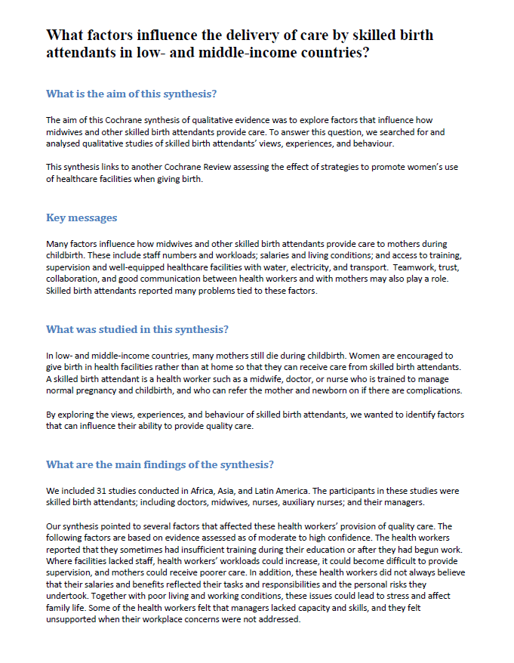
A
B
C
D
E
Example 1: In this plain language summary, the review authors have chosen to focus on the findings presented in the Summary of Qualitative Findings table.

The example is based on the following QES:
Munabi‐Babigumira S, Glenton C, Lewin S, Fretheim A, Nabudere H. Factors that influence the provision of intrapartum and postnatal care by skilled birth attendants in low‐ and middle‐income countries: a qualitative evidence synthesis. Cochrane Database of Systematic Reviews 2017, Issue 11

See also Appendix 2 for another example of a plain language summary.

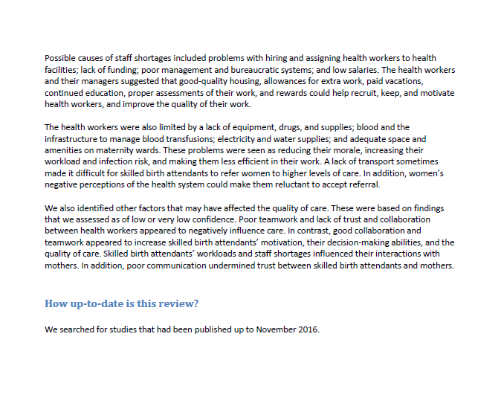
F

Instructions for each part

Qualitative Evidence Synthesis title
A
If the title of your synthesis is difficult to understand, for instance if it includes technical terms or jargon, consider re-writing it in plain language (consider doing this for the full synthesis and not just for the Plain Language Summary).
Suggested sub-heading: “What is the aim of this synthesis?”
B
People do not always understand that the results of a plain language summary come from a systematic review rather than from a single study. Some also wrongly assume that the review authors have carried out the studies themselves. We therefore suggest that you use an introductory sentence such as:
“The aim of this Cochrane qualitative evidence synthesis was to explore / find out if [….]. To answer this question, we/the review authors searched for and analysed relevant qualitative studies about [….].”

Where your synthesis is linked to one or more Cochrane intervention reviews, make the reader aware of this. For instance:
“This qualitative evidence synthesis links to a Cochrane review assessing the effect of [….].”

Suggested sub-heading: “Key messages”
C
It can be useful to present a very brief summary of your key findings, although this requires judgment and may be challenging. Consider whether you are able to formulate some brief key messages (280 characters will make this “tweetable”).
More detailed results should be presented in the section called “What are the main findings” below.

Suggested sub-heading: “What was studied in this synthesis?”
D
In this section, you should briefly describe the topic of the synthesis, for instance:
- Why this particular topic is important
- The phenomenon of interest that was addressed, for instance, the type of health care service or condition, perspective, and settings
- How the review topic was identified. For instance, was the review commissioned to support a particular guideline process; in response to gaps identified in other studies or reviews; or in response to the review authors’ experiences as healthcare providers or service users?
Avoid technical terms or jargon as much as possible, or where these are unavoidable, explain what these mean.

Where else in the synthesis is this information presented? You will also find information about the phenomenon of interest that the synthesis aims to cover in the Background section and in the Methods section, under “Criteria for considering studies for this review”.

Suggested sub-heading: “What are the main findings of this synthesis?”
E

Describing the included studies
In this section you should briefly describe the studies that you included in the synthesis. It may be enough to give information about the number of studies you included and where they were set. Sometimes you may also need to give more information. For instance, if the included studies only covered certain population groups, settings, services or conditions, this should be mentioned. You may also need to mention the funding sources of the included studies. For instance:

“We/The review authors found [x#] relevant studies. [X#] were from [country/setting] and [x#] were from [country/setting]. These studies primarily explored the views and experiences of [population] in [setting]. [x#] of the studies were funded by the manufacturer while [x#] were funded by government agencies.”

Where else in the synthesis is this information presented? You will also find information about the study populations, services or conditions and settings that the included studies covered in the Results section and in the Characteristics of Included Studies Table. You may also find information about how the studies were funded in the Characteristics of Included Studies Table.

Reporting the main findings
All EPOC qualitative evidence syntheses should include a Summary of Qualitative Findings table. You are also likely to have presented these findings in more detail in the main text. In addition, you may have developed a model, a line of argument, a theory or similar. Finally, your synthesis may have included some form of analysis where you link your findings with the findings from the related Cochrane Intervention Review(s). Because of word limits in the abstract and Plain Language Summary, you may need to focus on one or two of these elements when presenting your findings.
If you decide to focus on the findings presented in the Summary of Qualitative Findings tables, you may have to further summarise these. One option is to focus on those findings that have high or moderate confidence (Example 1). However, this may interrupt the logical flow of your results or your line of argument, and the extent to which this is a good option is likely to be review-specific. Another option is to focus on those findings that your readers are likely to regard as the most important. This is a judgment.

Other issues when presenting your findings
- Always refer to the level of confidence in your findings (i.e. the GRADE-CERQual assessments). The first time you refer to confidence, write it in full (i.e. “high/moderate/low confidence in the evidence”). After that, you can shorten this (i.e. “high/moderate/low confidence”)
- Where your confidence in a finding is high, your statements can be straightforward (e.g. “Patients were concerned about stigma….”). However, where your confidence in a finding is less than high, avoid strong statements and consider using modifying terms to indicate your lack of confidence (e.g. ““The evidence suggests that patients were concerned about stigma…”)
- Where your confidence in a finding is very low, avoid presenting this finding in the Plain Language Summary or, where the topic is likely to be important to readers, make it clear that your confidence in the evidence is very low
- Consider whether you want to highlight gaps in the findings, for instance perspectives or settings that the included studies did not cover
- When you have finalised the Plain Language Summary version of the findings, use the same information in the abstract
- Do not present recommendations!

Where else in the synthesis is this information presented? You will also find information about the synthesis findings in the abstract, summary of qualitative findings table and the results section. Ensure that findings are reported consistently across all of these sections.

Suggested sub-heading: “How up-to-date is this synthesis?”
F
State when the review authors searched for the included studies, for instance by saying:

“We/The review authors searched for studies that had been published up to [date].”

Where else in the synthesis is this information presented? You will also find information about the dates of the search in the Methods section, under “Search methods for identification of studies”

